**PRELIMINARY ANALYSIS**

**REPORT**

**AUTHORS**

**JAKOB | BRAYDEN | ALEX**

**Introduction:**

Our team of four has been assigned with developing an application designed to assist EITS with client administration and supporting client activity. The users of this application will select from a list of desired industries, within the industries it provides information about educational courses which they can take and the skills required for them. The administrator can then view and track this information from the system which recorded the users' name, email, number, and activity throughout the application. EITS would like this application to welcome clients to the office and track their attendance and training progress throughout their use on this application and would like the information to be accessible via her computer tablet to easily access and see the data. Our team must look for the necessary hardware and software like a desktop based database application and interface components to be developed for user access which might be from a computer tablet, laptop or PC and for software being a web-based database and windows based software.

**System Request Summary:**

EITS would like a new easily accessed system to track and view attendance, records, and results of the users. This system will need to have a database and GUI built using MySQL and NetBeans to allow EITS to easily view and obtain the necessary information she needs.

All requested features include:

* Welcoming clients to the office and tracking their attendance throughout the app
* Interacting with clients about training options based on the selected industry they desire to look at.
* Keeping a record of the clients' choices training and progress through each visit.
* For the system to store record details for later review, reporting and statistical reporting purposes and for later use to plan future company’s shops work practices.

**Findings:**

**Business Requirements:**

* Who was it built for ?: This application was built for EITS
* Goals: To create a new GUI application to allow clients to view and enrol in courses, admins to edit client and caseworker data and to implement and edit courses, and for caseworkers to view client data, attendance and progress.

**Process Requirements:**

The application must be able to allow clients, admins and caseworkers to interact with the GUI in an easy manner while also being connected to the database which in some cases they can modify and interact with it. This will be done through the sign up, client data (Admin), course list (Admin), Unit list (Admin) and Industry List (Admin) pages.

**Feasibility:**

For the project to take place, it must first be deemed technically feasible to develop and economically justifiable. The project must first be checked for not having too many resources before development to ensure the project is worth the investment. We must first check the required hardware, software and technologies to develop this project.

NetBeans, Sourcetree, MySQL, MS Project, and Windows 7,8, or 10 which are all software which is either free to use or the team already has at their disposal so the software and time management tools to develop this project is feasible.

The Hardware to develop this project requires an average system needing no more than 4 Core 2.5Ghz CPU, 4GB of RAM, 100 GB of storage, and a good connection to the internet. The Team already has systems with this level of hardware and more so the hardware to develop this project is feasible.

With the project only requiring a small database and GUI Interface to be developed and connected to each other, it is definitely feasible to construct on time and within budget to what is appropriate for the Project manager.

Some Constraints for the project development could be that a member of the development team has left so some features of the application might be delayed somewhat since the other developers must now take on the work of the team member who has left. This will impact the overall time and cost to develop the application.

**Number of pages:**

* Login
* Sign Up
* Course list
* Course list (Admin)
* Industry List (Admin)
* Unit List
* Unit List Alternate
* Unit List (Admin)
* Admin Panel (Admin)
* Caseworker Panel (Caseworker)
* Client Data (Admin)
* Client Data (Caseworker)
* Client Progress (Caseworker)
* Client Attendance (Caseworker)
* 2 Thank you and 1 error message pages

**Recommendations:**

Recommendations for going about developing and planning the application is to firstly have easy and effective communication between team members. This would be done through an online chat service, primarily Discord. Discord is a free online chat service which allows multiple people to join in on a call and easily share their screens. This will allow all team members to easily work together and help each other with problems which might arise. Finding and using a quality chart service will improve communication and overall performance of the group leading to a higher quality product.

Another recommendation is that we must be reasonable about what we can accomplish and not try to produce or develop something that just isn't practical. This will just waste time and resources and lead to a failed project. Instead, we must develop an application which is within our time and cost budget and can be done by all team members.

**Time and Cost Estimates:**

For our team to complete this project on time and in budget we will have planned and utilised the necessary tools, programs, hardware and tactics. This will also give us a good understanding of the total cost and budget for the project and how long the development will take and assist us from running late and in to delays. To do this we would have used programs such as Microsoft Project to plan out our schedules and deadlines for each task and to allocate costs to each task to get an accurate budget which the team must remain in. As a development team our primary goal is to make profits, and doing so requires restricting ourselves and having a clear idea for everything which the client wants developed to find the overall cost for the project.

Using the project management tool Microsoft Project we have created an estimate for the time and cost it will take to complete our project. We took in to account the required work requested by the client such as the amount of pages and features needed and also the implementation of the database, our limitations as a group also including a team member which has left, and the required hours it would take for each developer to get the application developed in time.

Our total cost and time estimate for the project is $17,200. This is estimated from the time frame of the 18th of May to the 18th of June or 31 days at an hourly rate of $100 while the initial client meeting is $50 an hour.

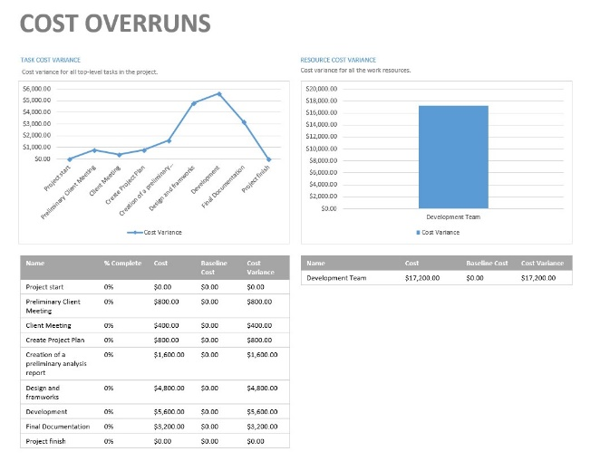

**Expected Benefits:**

The expected benefits for creating this application and database is that it will boost student enrolments and overall sales by improving access to information and allowing them to easily navigate and discover information about the industries, courses and their units, and if it will be a good fit for them overall increasing profits for EITS. With the creation and linking of the database it will also increase organisational productivity and overall organisation since now all EITS admins and caseworkers can easily navigate to and see client enrolments and client data.

**ER Diagram (Or Equivalent):**

**Screen Designs:**

**Design:** The specific colours and design of each page have been selected to create and allow for a simple and easy to use experience for clients, caseworkers and admins. This have been achieved by implementing colours which pare together nicely and a dark theme to protect against eye strain for users and to make it easy on the eyes. Each page remains consistent with its layout and colours to keep a flowing and familiar feel to the application.

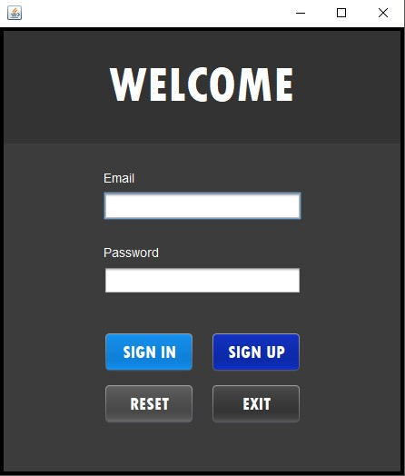

**Login Screen**

Functionality: The functionality for this page is to link and tie all pages together. The welcome page is used to enter an email and password which has already been given to you inside the database. The welcome screen displays four buttons

* Sign in: Used to log the user in from the database
* Sign up: Used to put a user in to the database.
* Reset: Used to reset the text inputted
* Exit: Used to exit the application.

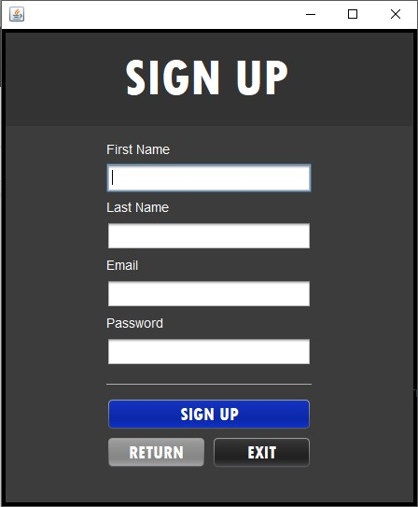

**Sign Up Screen**

Functionality: The functionality for the signup page is to allow a user to input their first name, last name, email and password and for it to be registered inside the database to be later used to login with. The Signup screen displays three buttons

* Sign up: Logs the information given in to the database
* Return: Takes the user back to the Login screen
* Exit: Used to exit the application

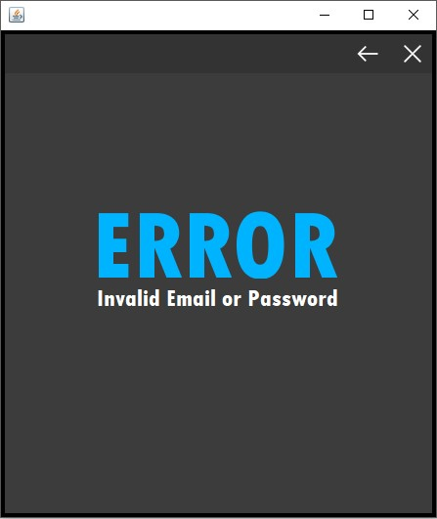**Error Invalid Email or Password**

Functionality: This page is used to alert the user that their email or password which they entered in to the login page is incorrect or invalid. The error page displays two buttons

* Return: Takes the user back to the Login screen
* Exit: Used to exit the application

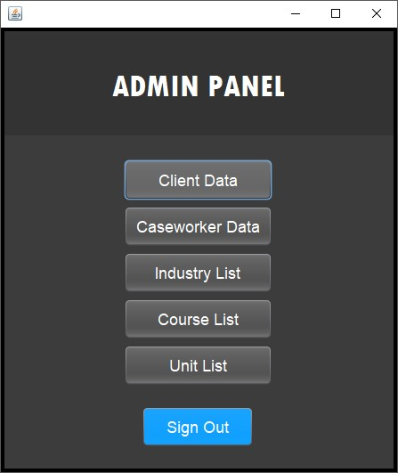**Admin Main page**

Functionality: This page is the main panel display for admins after they login. They can see all panels and controls they have access to and can also sign out. There is 6 buttons on this page.

* Client Data, Caseworker Data, Industry List, Course List, Unit List take you to their respective pages for the admin to edit and view the information.
* Sign out: Signs out the admin and takes you back to the login page

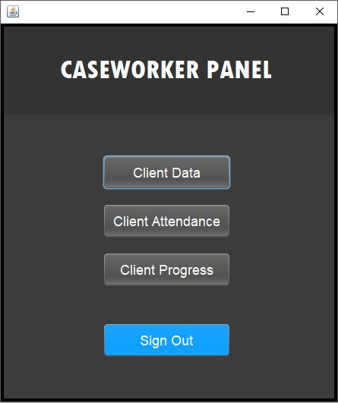**Caseworker Main page**

Functionality: This page is the main panel display for caseworkers after they have successfully logged in. They can all the panels and controls they have access to and can also sign out. Unlike admins caseworkers cannot edit, insert, or update data but only view it. There is 4 buttons on this page.

* Client Data, Client Attendance, Industry List, Course List, Unit List take you to their respective pages for the admin to edit and view the information.
* Sign out: Signs out the admin and takes you back to the login page

**Client Data Admin page**

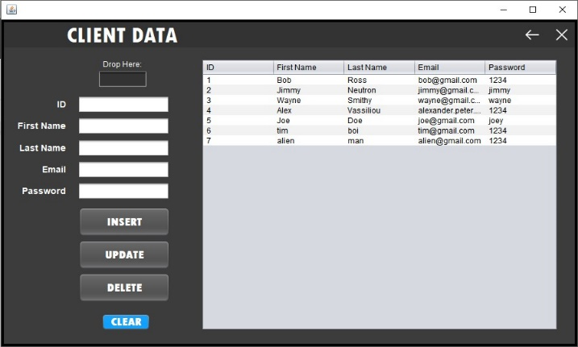Functionality: This page allows an admin to view, insert, update or delete client data inside the database. The Client data admin page displays 6 buttons and a drop here box.

* Drop here: Drag and drop information from the table in to the drop here box to display the information in the boxes underneath
* Clear: Clears information inside the text boxes
* Insert: Inputs text inside the text boxes in to the database
* Update: Updates the existing information with modified text inside the text boxes.
* Delete: Deletes the selected client data from the database
* Back: Takes you back to the admin main GUI
* Exit: Closes the application

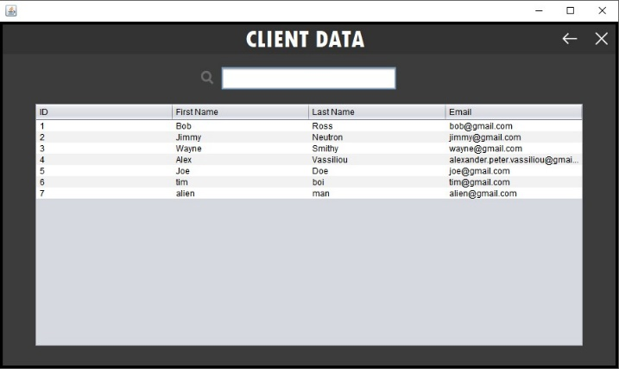**Client Data Caseworker Page**

Functionality: This page allows a caseworker to only view and search the client data but does not allow them to insert, update or delete any information. The client data caseworker page displays 2 buttons and a search box

* Back: Takes you back to the caseworker main GUI
* Exit: Closes the application
* Search: allows you to type in a client’s name and it automatically appears at the top.

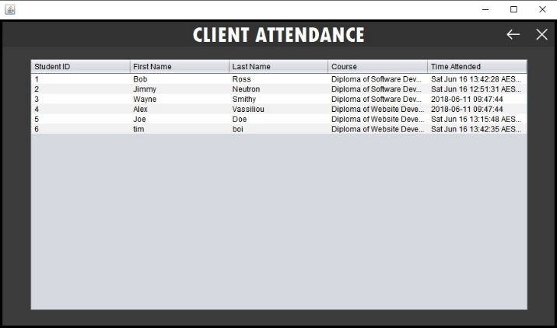

**Client Attendance Page**

Functionality: This page allows a caseworker to view and search individual client attendance throughout the application and see when clients login. This page has 2 buttons

* Back: Takes you back to caseworker main GUI
* Exit: Closes the application

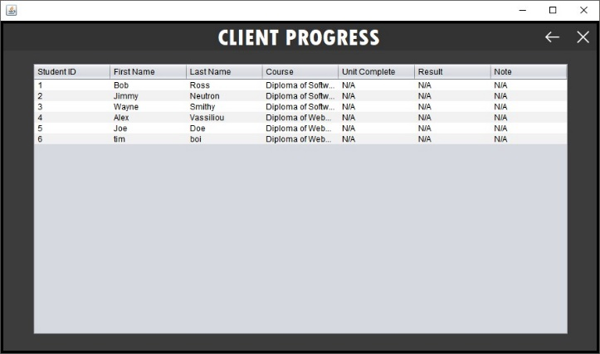  
**Client Progress Page**Functionality: This page allows a caseworker to view and search individual client progress, enrolments and results. This page displays 2 buttons

* Back: Takes you back to caseworker main GUI
* Exit: Closes the application

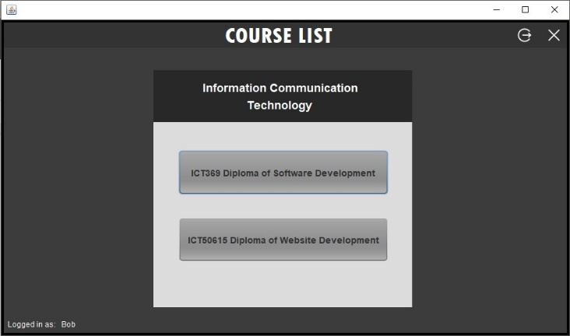  
**Client Course List Page**

Functionality: This page is the main page after the login screen clients will see when signing in. A client is displayed two courses to choose from. This page displays 4 buttons

* Sign Out: Takes you back to login page
* Exit: Closes the application
* First and second course: Takes you to the first and second course to choose what you want to enrol in.

**Client Unit List Page**

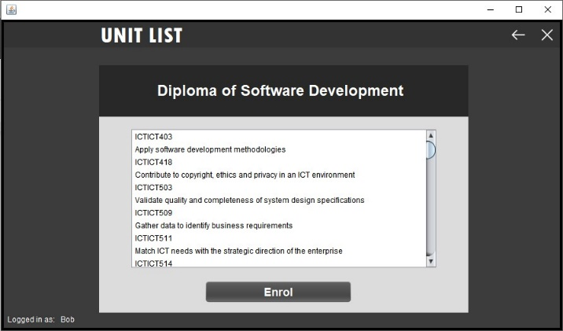Functionality: This page is the unit list page which displays all the units within the selected course. From here the client can decide to enrol in the course and it will be updated in the database. There is also a client unit list alternate page which is for the second course but is the same layout as this page. There is 3 buttons

* Back: Takes you back to client course list page
* Exit: Closes the application
* Enrol: Enrols the logged in user in the certain course they picked.

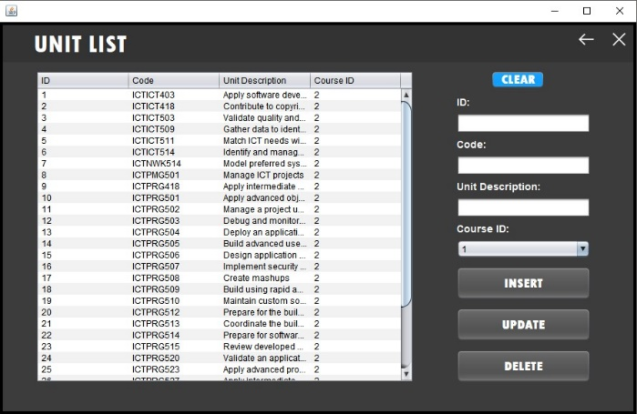  
**Client Unit List Admin Page**

Functionality: This page is the unit list admin page and displays all the units for each course for the admin to insert, update, and delete original or new units. There are 6 buttons on this page

* Back: Takes you back to Admin Main page
* Exit: Closes the application
* Clear: Clears information inside the text boxes
* Insert: Inputs text inside the text boxes in to the database
* Update: Updates the existing information with modified text inside the text boxes.
* Delete: Deletes the selected unit data from the database

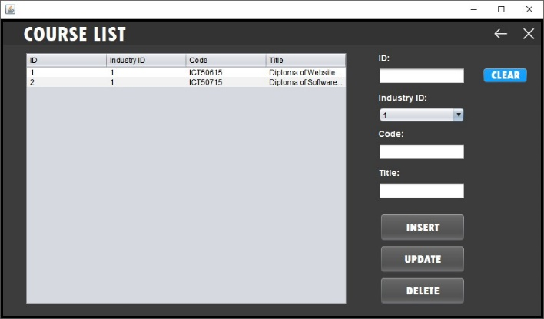**Client Course List Admin Page**

Functionality: This page is the course list admin page and displays all the courses for each industry for the admin to insert, update, and delete original or new courses. There are 6 buttons

* Back: Takes you back to Admin main list page
* Exit: Closes the application
* Clear: Clears information inside the text boxes
* Insert: Inputs text inside the text boxes in to the database
* Update: Updates the existing information with modified text inside the text boxes.
* Delete: Deletes the selected course data from the database

**Client Industry List Admin Page**

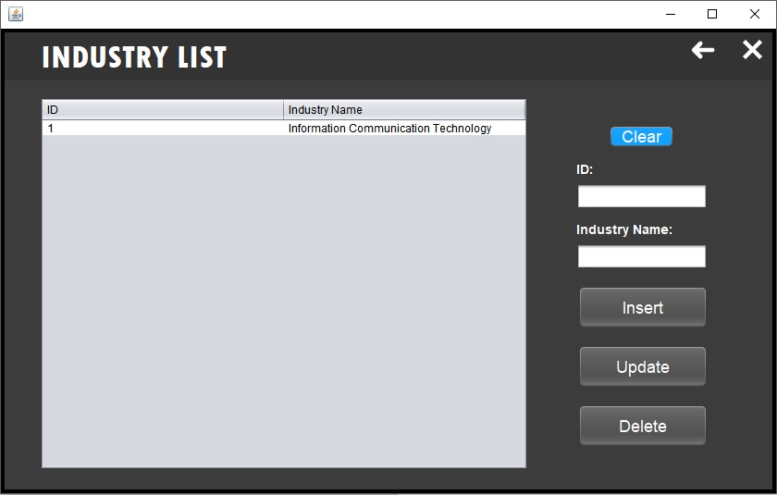

Functionality: This pages is the industry list admin page which allows admins to insert, update and delete existing or new industries in the database. This page consists of 6 buttons

* Back: Takes you back to admin main page
* Exit: Closes the application
* Clear: Clears information inside the text boxes
* Insert: Inputs text inside the text boxes in to the database
* Update: Updates the existing information with modified text inside the text boxes.
* Delete: Deletes the selected industry data from the database

**Caseworker data Admin Page**

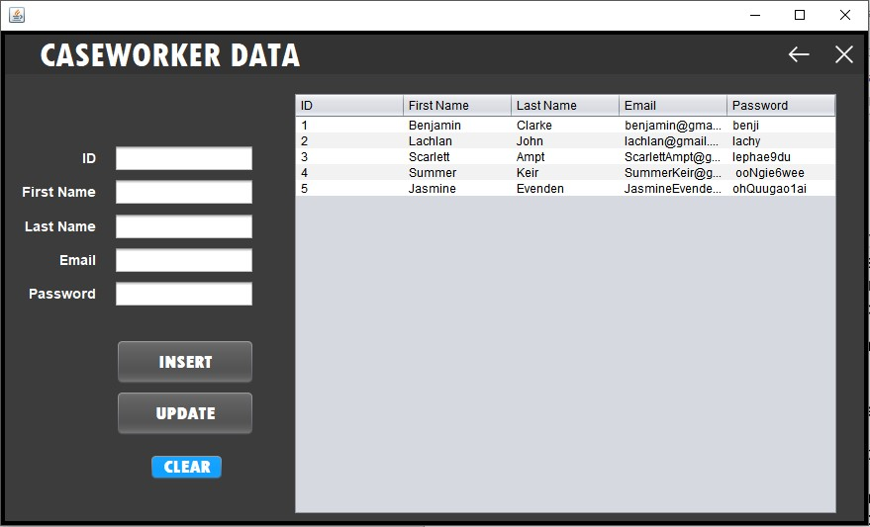

Functionality: This page is the caseworker data admin page which allows admins to insert and update existing or new caseworkers in to the database. Admins cannot however delete existing caseworkers from the database. There is 5 buttons on this page

* Back: Takes you back to admin main page
* Exit: Closes the application
* Clear: Clears information inside the text boxes
* Insert: Inputs text inside the text boxes in to the database
* Update: Updates the existing information with modified text inside the text boxes.

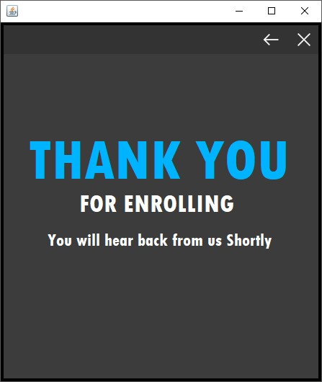

**Thank you enrolment page**

Functionality: This page is the thank you for enrolling page which displays after a client has enrolled in a course. There is two buttons on this page

* Back: Takes you back to course list page
* Exit: Closes the application

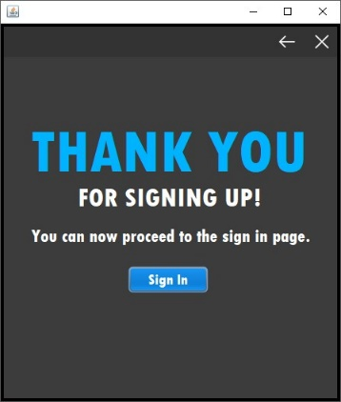**Thank you sign up page**

Functionality: This page is the thank you for signing up page and displays after a client has successfully sign up their account. There is three buttons on this page

* Back: Takes you back to the sign up page
* Exit: Closes the application
* Sign In: Takes you to the login page so the client can sign in with their new account.